Annual Parade and Awards Presentation 2017
Announcement for Squad and Color Party
Units must attend ONE of the training days and rehearsal day in advance. At least 10 Squad members including the commander should attend the mentioned training or they will be rejected for joining the Annual Parade.
《Training Day》Must Attend ONE of the following days
Training | Dates | Time | Venue
1 | 14th October, 2017  (Saturday) | 2:30pm – 5:30pm | Island Centre,  Rm 604, 6/F, On Sin House,  Oi Tung Estate, Shau Kei Wan (Map 1)
2 | 21st November, 2017  (Saturday) | 2:30pm – 5:30pm | S.K.H. Chu Oi Primary School 45 Tung Chi Street, Shek Yam, Kwai Chung, N.T.(Map 2)
《Rehearsal Day》
Rehearsal | Date | Time | Venue
Rehearsal | 18th November, 2017  (Saturday) | 2:30pm – 5:30pm | Mong Kok Stadium  37 Flower Market Road(Map 3)
*Please wear Outdoor Uniform for rehearsal
《Annual Parade》
Parade | Date | Time | Venue
Parade | 19th November, 2017  (Sunday) | Whole day | Mong Kok Stadium  37 Flower Market Road
*To protect the grass, please don't wear thin high heels
Remarks
- Must attend with FULL Uniform and hat.
- Girls with long hair, please tidy up your hair by hair clips.
- Please bring enough drinking water and rain coats, lunch should be prepared as well. Arrangement for raining - Only transparent rain coat is allowed on the parade day, but no limitation for the training and rehearsal day. It is suggested to be in light color and convenience.
- Units must bring the items needed : Pole, Flag Sets, and Unit Flags
- Units must attend ONE of the training day. At least 10 Squad members including the commander should attend the mentioned training or they will be rejected for joining the Annual Parade.
- The Draft of Parade Order is attached. Please be noted that there may be amendments. (See Appendix 1)
(Map 1)
Island Centre (Rm 603, 6/F, On Sin House, Oi Tung Estate, Shau Kei Wan)

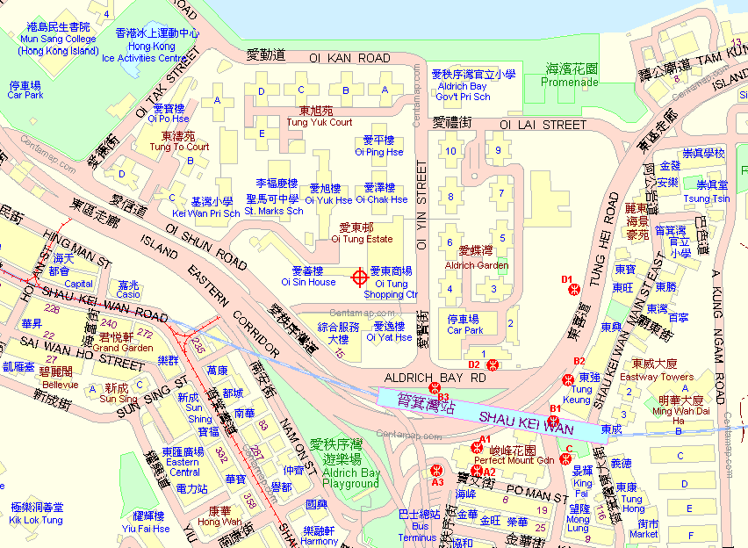
Shau Kei Wan MTR Exit D2

(Map 2)

S.K.H. Chu Oi Primary School (45 Tung Chi Street, Shek Yam, Kwai Chung, N.T.)

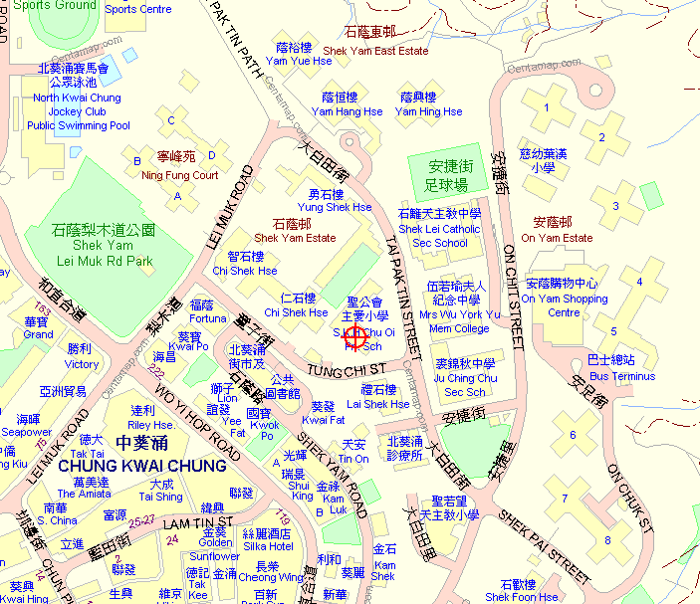
Minibus Stop: 86
Bus Stop: 235M
Minibus Stop: 86M

(Map 3)
Mong Kok Stadium (37 Flower Market Road)

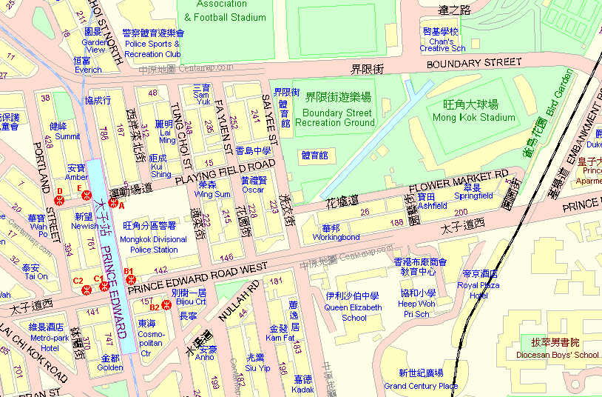
Prince Edward MTR Exit A

太子地鐵站A出口
Appendix 1
The Hong Kong Girl Guides Association
Annual Parade
19th November 2017
Parade Order

PC – Parade Commander RO – Reviewing Officer
DPC – Deputy Parade Commander MC – Master of ceremony
SC – Squad Commander

EVENT | S/N | PERSON | WORDS OF COMMAND | MOVEMENT
Parade Assembly |  |  |  | - Squad members report to respective SCs at the designated assembly area.  - Colour parties gather at the designated assembly area.
Parade Assembly |  | SC | Squad ____, fall IN | - Squad members fall in under the instructions of the working members at the assembly area.  - Only half-arm dressing in the assembly area.
Parade Assembly |  | SC | Squad ____, move to the left-in-threes, left TURN | - Squads move to the left with SCs leading
Parade Assembly |  | SC | Squad ____, stand at EASE | - Squads stand at ease
Parade March In | 1 | DPC | Parade, atten-TION | - All parade members come to attention
Parade March In | 2 | DPC | Colour parties, flag at the CARRY | - Colour Parties carry their flags
Parade March In | 3 | DPC | Parade march IN | - DPC leads Association Colour Party & Section Colour Parties march in  - Colour Parties march in at the same time  - Band plays the marching music
Parade March In | 4 | SC | Squad ____, by the right, quick MARCH | - Other squads march in
Parade March In | 5 | SC | Squad ____, HALT | - Squads halt at their designated area.
Parade Forming Up | 6 | DPC |  | - DPC marches to the commanding position herself and halt  - Turn and facing the parade.  - Association Colour Party & Section Colour Parties halt at their designated area.  - All squads halt at their designated area.  - Colour parties halt at their designated area.
Parade Forming Up | 7 | DPC | Parade will advance, right TURN | - Parade right turn, facing the front  - After right turn, on the 1st heavy drumbeat, SCs march to SC POSITION (timing 1-8, halt, check, 1, 2). SCs left turn on the 2nd drumbeat, bend knee on the 3rd drumbeat
Parade Forming Up | 8 | DPC | Section Colour Parties, forming single rank, form single RANK | - Flag bearers in the centre rank stand still, front rank escorts take one pace to the right and one pace step back, rear rank escorts one pace to the left and one pace forward (timing 1, 1, 2)  - Result in 4x3 groups of Colour Parties’ formation.
Parade Forming Up | 9 | DPC | Parade dressing, right DRESS | - SCs about turn at command, adjust to the centre of her squad.  - On the 1st heavy drumbeat, all parade members RIGHT DRESS / Section Colour Parties INWARD DRESS.  - Drum rolls for 10 seconds for the parade to take dressing by the right / Section Colour Parties to take dress by the CENTRE.  - On the 2nd heavy drumbeat, all parade members EYES FRONT / Section Colour Parties EYES FRONT, SCs about turn. Bend knee on the 3rd drumbeat.
Parade Forming Up | 10 | DPC | Colour Parties, flag at the ORDER | - Colour Parties order flag
Parade Forming Up | 11 | DPC | Parade, stand at EASE | - Parade stand at ease  - DPC about turn facing the dais, stand by to hand over the parade to PC
Handing Over and Taking Over the Parade | 12 |  |  | - PC marches in
Handing Over and Taking Over the Parade | 13 | DPC | Parade, atten-TION | - Parade attention and welcome PC
Handing Over and Taking Over the Parade | 14 | DPC | Colour Parties, flag at the CARRY | - Colour Parties carry flags
Handing Over and Taking Over the Parade | 15 | DPC | “Good Afternoon, Madam. The parade is now handover to you, Madam.” | - DPC marches up to PC and salutes, hand down after PC hand down.
Handing Over and Taking Over the Parade | 16 | PC | “Thank you.” | - DPC salutes again and down after PC’s hand down.  - DPC About turn, marches back to commanding position and about turn facing PC
Handing Over and Taking Over the Parade | 17 | PC | Colour Parties, flag at the ORDER | - Colour Parties order flag.
Handing Over and Taking Over the Parade | 18 | PC | Parade, stand at EASE | - PC about turn facing the dais, then stand at ease, waiting for the arrival of RO.
Arrival of RO and Official Party | 19 | PC | Parade, atten-TION | - PC comes to attention first  - All parade members come to attention
Arrival of RO and Official Party | 20 | PC | Colour Parties, flag at the CARRY | - Colour Parties carry flags
Arrival of RO and Official Party | 21 |  |  | MC will invite all guests to stand up to welcome the official party
Flag Rising | 22 |  |  | - PRC song play  - PC/DPC/SC full salute – up when PRC song start  - Salute – down when PRC song end
Flag Rising | 23 |  |  | - Association flag rising carry on.  - MC “Salute to the COLOURS”  - PC, DPC, SCs full salute  - Salute – down when flag raise to the top
Flag Rising | 24 |  |  | MC will ask all guests to be seated
General Salute to RO | 25 |  |  | MC invites RO on dais, to receive the General Salute.
General Salute to RO | 26 | PC | Parade, general salute, SALUTE | - PC/DPC/SC salute when play first heavy strike of drum  - Band plays “General Salute” music.  - PC/DPC/SC salute. Other parade members stand still.  - On the last heavy drumbeat, all commanders hands down.
Speech by RO | 27 | PC | Colour Parties, flag at the ORDER | - Colour Parties order flag.
Speech by RO | 28 |  | Parade, stand at EASE | - Parade stand at ease.  - Ceremony carries on.
Renewal of the Promise | 29 | PC | Parade, atten-TION | - PC first comes to attention herself.  - All parade members come to attention.
Renewal of the Promise | 30 |  | Colour Parties, flag at the CARRY | - ALL Colour Parties carry flag.
Renewal of the Promise | 31 |  |  | - Ceremony carries on.  - All squad members SALUTE (Guide Sign) and then renew their promise.  - Colour Parties stand still with SALUTE.
Presentation of Souvenir to RO and Speech by CC | 32 | PC | Colour Parties, flag at the ORDER | - ALL Colour Parties order flag
Presentation of Souvenir to RO and Speech by CC | 33 |  | Parade, stand at EASE | - Parade stand at ease
Presentation of Souvenir to RO and Speech by CC | 34 |  |  | - Ceremony carries on, until CC finishes her speech.
RO address | 35 |  |  | - Whole parade remain at ease  - RO remain on dais waiting for parade march past
Parade March Past and March Off | 36 | PC | Parade, atten-TION | - PC first come to attention herself  - All parade members come to attention
Parade March Past and March Off | 37 |  | Colour Parties, flag at the CARRY | - Colour Parties carry flag
Parade March Past and March Off | 38 |  | “Good afternoon Madam/Sir. May I have your permission to march past and march off the parade, Madam/ Sir?” | - PC marches up to RO, salutes and reports.  - Wait for RO’s reply
Parade March Past and March Off | 39 | PC | “Thank you, Madam/Sir.” | - PC salutes again and resumes commanding position.  - Turn and facing dais.
Parade March Past and March Off | 40 | PC | Section Colour Parties, forming three ranks, form three RANKS | - Section Colour parties will reform to a squad formation with flag bearers in the centre rank. Flag bearers in the second file stand still. Last file (front rank escorts) take one pace forward and one pace to the right. First file (rear rank escorts) one pace backward and one pace to the left (timing 1, 1, 2)
Parade March Past and March Off | 41 |  | Parade will march past and march off, move to the right in columns of route, right TURN | - Parade and Section flag party right turn  - With the 1st heavy drumbeat, PC/SCs march to marching positions. (timing 1-8, halt, check, 1, 2)  - After halting at respective position, PC/SCs left turn on the 2nd drumbeat, bend knee on the 3rd drumbeat.
Parade March Past and March Off | 42 |  | Colour Parties, by the centre, quick MARCH | - Band strikes and play marching music  - PC and Association Colour Party march on and then Section Colour Parties.
Parade March Past and March Off | 43 | SC | Squad____, by the left, quick MARCH | - Squads march on in turn  - SC should keep her distance of 10 paces from the rear of the squad in front
Parade March Past and March Off | 44 |  |  | - All other squads march off as per the route.
March Off | 45 | SC | Squad____, by the right, eyes RIGHT | - SC gives the command when passing the 1st marker  - SC salutes to the right, all general squad members except right-marker eye right
March Off | 46 | SC | Eyes FRONT | - SC gives the command when passing the 4th marker
Fall Out | 47 | SC |  | - Squads fall out at the designated area and return to respective spectator stand.

