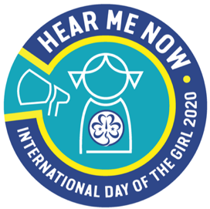**The Hong Kong Girl Guides Association**

**International Day of the Girl 2020**

**#HearMeNow Badge Collection Form**

After completing the required activities in the “International Day of the Girl 2020 #HearMeNow” Activity Pack, Appointed Guiders can complete this form and submit to the Programme Department to apply for the #HearMeNow badges for their unit. The office will try to arrange the badges for collection on the designated date as provided by the Guider. Badges will only be given to members who have completed the IDG 2020 #HearMeNow Challenges and each member can receive one free badge only.

Name of Guider: Division: ____________ District:

Unit Number: __________________________ □ Brownie □ Guide □ Ranger

Contact Number: _______________________ Email: ____________________________

No. of badge requested: ___________ (one badge for each girl)

Signature of Guider: ________________ Expected collection date: ________________

Members who have completed the IDG 2020 #HearMeNow Activities

|  |  |  |  |
| --- | --- | --- | --- |
|  | Name |  | Name |
|  |  | 16. |  |
|  |  | 17. |  |
|  |  | 18. |  |
|  |  | 19. |  |
|  |  | 20. |  |
|  |  | 21. |  |
|  |  | 22. |  |
|  |  | 23. |  |
|  |  | 24. |  |
|  |  | 25. |  |
|  |  | 26. |  |
|  |  | 27. |  |
|  |  | 28. |  |
|  |  | 29. |  |
|  |  | 30. |  |

Please submit the form via post, fax, e-mail or in person

(Address: 8 Gascoigne Road, Kowloon, Hong Kong Fax: 2782 6466 Email: [tpg@hkgga.org.hk](mailto:tpg@hkgga.org.hk))

Collection Time: Monday to Friday, 9:00a.m. to 5:30p.m. (Except Public Holidays)