1 – 24 OCTOBER 2021  HELEN STORROW SEMINAR 2021  (Online)  Application is now OPEN!  The Helen Storrow Seminar is WAGGGS' introductory level leadership development event.  The seminar gives young people from around the world the chance to connect on issues they care about and take the lead as agents of change in their communities.  This special programme has been held at Our Chalet, WAGGGS’ World Centre in Switzerland, since 1986. But due to epidemic, the seminar held by online this year and allows participants to explore the environmental issues they face in their communities and inspires them to value and protect the environment in a different way.  Event Fee: HK$1,000 (Association subsidizes HK$1,000 for each qualified participant)  *Please note that once your application has been sent to WAGGGS after selected by HKGGA, you are required to bear the full cost (HK$2,000) if you withdraw from the event.  Application Deadline: 25th June 2021 (Friday)  Interview Date: 5th July, 2021 (Details will be announced) | 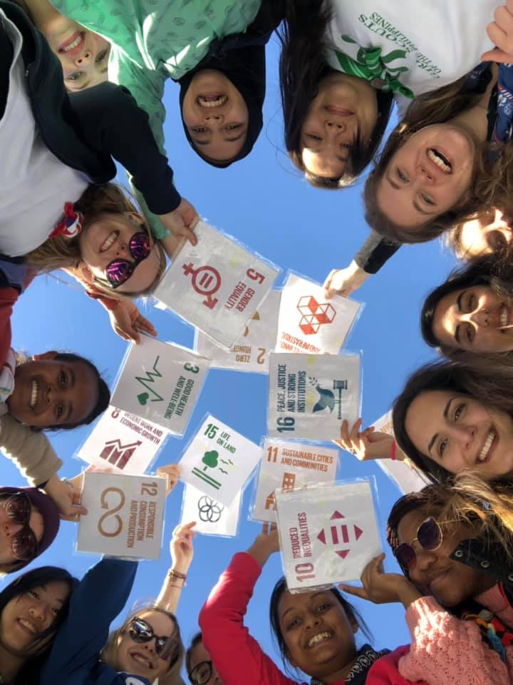 | 18 - 25 years old?  Rangers or Guiders?  Not have participated in any WAGGGS seminar before?  Passionate about Environmental Issues?  Eager to Develop New Leadership Skills?  Enquiry  International and China Liaison Office  intl@hkgga.org.hk
• Certificate of Participation
APPLICATION FORM

Please complete this form and return by email to intl@hkgga.org.hk by 25 June 2021. Your application must be completed in full and approved by the Association to be considered.
The Helen Storrow Seminar is taking from 1st to 24th October,2021.
Personal Information: (please write clearly using capital letters)
Full Name (as it is written in your passport) | Date of Birth
Address (including country) | Nationality
 | Gender
 | Email
 | Telephone / Mobile phone
Emergency Contact Details (please name the person you would like us to contact in the event of an emergency during the event)
Name: Address (including country):
Relationship to Applicant:
Telephone/ Mobile phone:
Email:
WAGGGS’ Member Organisation Name | Languages Skills (please tick as appropriate)  English  Native speaker Fluent Intermediate Basic None  French  Native speaker Fluent Intermediate Basic None  Spanish  Native speaker Fluent Intermediate Basic None  Arabic  Native speaker Fluent Intermediate Basic None  Other languages spoken (please specify):
Current Position(s) in your Member Organisation

Current occupation:
WAGGGS has limited funds for scholarships to the Helen Storrow Seminar, to enable Girl Guides and Girl Scouts to take part who could not otherwise have done so. The more you can fund your own trip, the more participants WAGGGS can support. The cost of the seminar is 200 GBP (excluding travel costs).
I would like to apply for financial assistance towards the seminar fee:
Yes (Full Scholarship) No
Yes (Partial Scholarship, specify amount)________GBP
Why you?
Helen Storrow Seminar participants should:
- Be active members of a WAGGGS Association
- Be 18 - 25 years old at the start of the event
- Be able to understand and communicate well in English
- Not have participated in any WAGGGS seminar before
- Be passionate about environmental issues
- Be committed to designing and running an environmental project in the wider community
- Be eager to develop new leadership skills and support their Association
- Be a mature and responsible global citizen
What makes you a great participant for the Helen Storrow Seminar?

What is most exciting about the Helen Storrow Seminar?

How will you use this leadership development opportunity to benefit your Association?

About your project
The Helen Storrow Seminar is a chance to make a real difference to an environmental issue that affects your community, and to go on a journey with other young people to form a network of global change agents.

The project that you will design and carry out is the heart of this experience, and we will be selecting applicants both on how they fit the participant criteria, and on the strength of their project ideas.

You will have lots of support before, during and after the seminar to turn your ideas into a real project, and we are looking for participants who are really motivated and inspired to make a change.

So, please answer the following questions as fully as you can:
What made you passionate about protecting the environment?

Which environmental issue(s) do you think most need action in your community?

What ideas do you have so far for how to tackle this issue?

How could you involve Girl Guides and Girl Scouts to make your ideas a reality?

Questions other than projects:
Why would you think you should be selected for the seminar?

How are you planning to make a difference to guiding experience for girls in your own unit, district, division, region and/or HK-wide upon your return from the event?

Consent

I consent to having my photograph taken and for any media that features me (photos, videos, quotes, etc) to be used by the World Association of Girl Guides and Girl Scouts (WAGGGS) and the Hong Kong Girl Guides Association (HKGGA):
Yes No
I fully understand that the event fee will not be refunded under any circumstances if my application has been sent to WAGGGS after selected by HKGGA. I will be responsible to bear the full cost (HK$2,000) if I withdraw from the event.
WAGGGS will use the personal information that you provide in accordance with applicable data protection laws to arrange your attendance at the Helen Storrow Seminar. Please tick here to give WAGGGS permission to use information about your health and nationality that you have provided to WAGGGS in this form.

By ticking this box I give permission, in accordance with the UK 2018 Data Protection Act, for WAGGGS to process and store my personal data for the purposes this seminar as described in the WAGGGS data protection policy (www.wagggs.org/en/privacy-cookies).

WAGGGS would like to keep you up-to-date with news and information about their leadership events and other opportunities which they think may be of interest to you. Please tick if you wish WAGGGS to contact you occasionally by email.
I have read and agree with the above statement

Signature

Applicant:
Name | Signature | Date

Nominator (Unit Guider or Supervising Commissioner):
Name | Signature | Date

