

**19th - 21st of November 2021**

The **Youth Wave Summit** is organised by The Polish Scouting and Guiding Association (ZHP) and will **take place online**. It offers the opportunity to spread the voice of young people by creating a space for dialogue around today’s essential subjects: **climate change, civic engagement and the well-being of young people.**

If you:

* are between 14 and 17 years of age during the online Summit
* are a current HK Girl Guide member
* respect Scouting and Guiding values
* are interested in current global problems (climate change, social inequalities, etc)
* want to be an active part of an international Scouting and Guiding Summit
* are not afraid to express your opinion in an online meeting in front of other people
* are able communicate in English
* are able to speak and act in public
* are open to look at the world from different perspectives

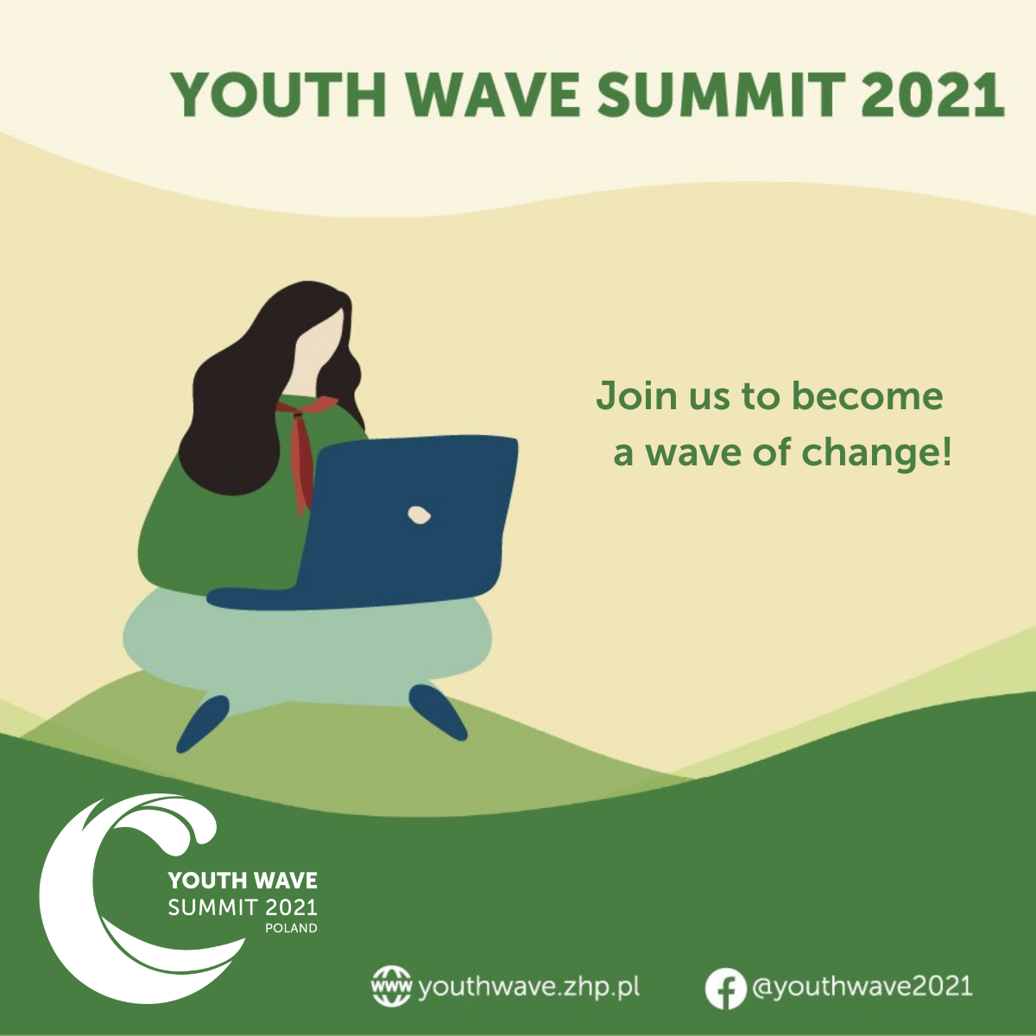

|  |  |
| --- | --- |
| **APPLICATION FORM**  Please complete this form and return by email to intl@hkgga.org.hk by 1st October 2021. Your application must be completed in full and approved by the Association to be considered, and an interview will be conducted. | |
| Personal Information: | |
| Name: | Surname: |
| Postal Address: | Date of Birth (DD/MM/YYYY): |
| Email: |
| Telephone / Mobile phone: |
| Languages Skills (please tick as appropriate) | English  □Native speaker □Fluent □Intermediate □Basic □None |
| Unit Number: | Position in unit: |
| Years/Form: | Name of School/Institute: |
| ***Applicants must complete the following tasks:*** | |
| Task 1: Prepare a short video in English between 3 and 5 minutes  Participants to introduce themselves and answer the following questions:  ► What is your name and where are you from?  ► What would you like others to know about you?  ► Why do you want to participate in the Youth Wave Summit?  ► If you could change one thing in the world for all the people – what would it be and why?  Please insert the video link here: | |
| Task 2: Write a short answer to the following question: If you have sufficient amount of funds for a project to help change your local community (your neighbourhood, district or your city etc.) what would you like to do and why? (max. 800 characters)  Answer: | |
| Other questions for us to know more about you:  Why do you think you should be selected for the Summit?  Answer: | |
| What are the climate change problems that Hong Kong is facing?  Answer: | |
| **Consent**  I consent to having my daughter’s photograph taken and for any media that features my daughter (photos, videos, quotes, etc) to be used by the World Association of Girl Guides and Girl Scouts (WAGGGS), The Polish Scouting and Guiding Association (ZHP), and the Hong Kong Girl Guides Association (HKGGA):  □Yes □No  WAGGGS/ZHP/HKGGA will use the personal information that you/my daughter provide in accordance with applicable data protection laws to arrange my daughter’s attendance at the Youth Wave Submit. Please tick here to give WAGGGS/ZHP permission to use information about your health and nationality that you have provided to WAGGGS/ZHP in this form.  □ WAGGGS/ZHP/HKGGA would like to keep you/your daughter up-to-date with news and information about their leadership events and other opportunities which they think may be of interest to you. Please tick if you wish WAGGGS/ZHP/HKGGA to contact you occasionally by email.  □ I have read and agree with the above statement  **Signature**  *Parent/Guardian:*   |  |  |  | | --- | --- | --- | | *Name* | *Signature* | *Date* | | |
| **Signature**  *Applicant:*   |  |  |  | | --- | --- | --- | | *Name* | *Signature* | *Date* |   *Nominator (Unit Guider):*   |  |  |  | | --- | --- | --- | | *Name* | *Signature* | *Date* | | |