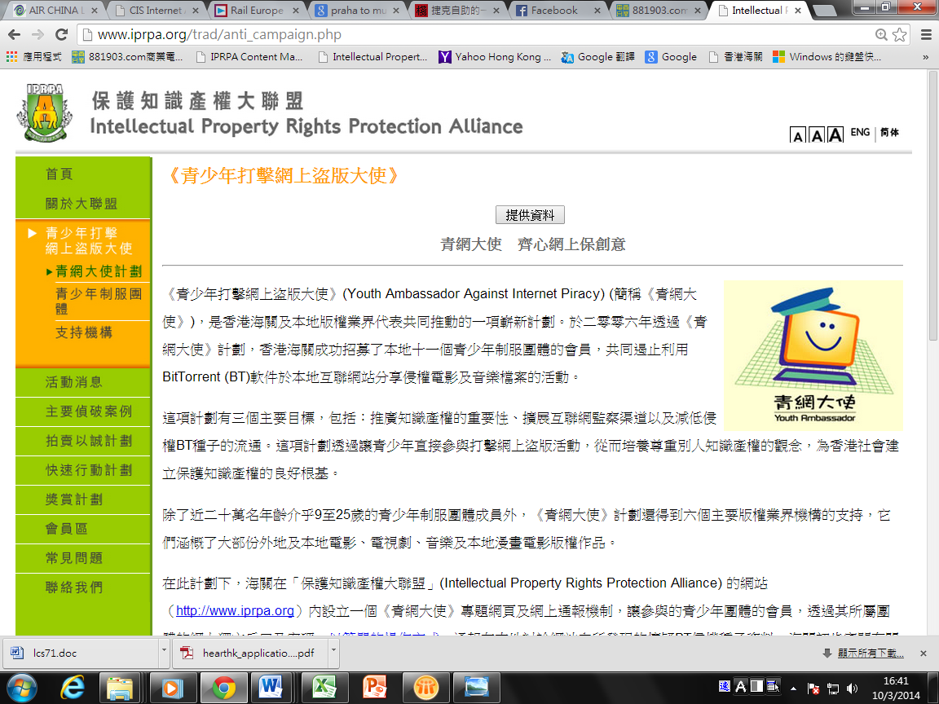

**2017粵港青少年知識產權交流活動**

**報名表格**

**(一) 個人資料**

|  |  |
| --- | --- |
| 相片:  (請張貼證件相於右欄) |  |
| 所屬團體名稱: | 香港女童軍總會 |
| 隊號: |  |
| 中文姓名: |  |
| 英文姓名: |  |
| 性別: |  |
| 年齡: |  |
| 聯絡電話: |  |
| 電郵地址: |  |
| 就讀學校: |  |
| 級別: |  |

請填妥此報名表格及提交背頁的短文論述，並電郵至 circle.huen@hkgga.org.hk 或郵寄至：九龍加士居道8號 香港女童軍總會一樓程序部，並註明「粵港青少年知識產權交流活動」。

**(二) 短文論述**

請就以下題目闡述己見(不少於100字):

**知識產權與我的日常生活**

___________________________________________________________________________

___________________________________________________________________________

___________________________________________________________________________

___________________________________________________________________________

___________________________________________________________________________

___________________________________________________________________________

___________________________________________________________________________

___________________________________________________________________________

___________________________________________________________________________

___________________________________________________________________________

___________________________________________________________________________

___________________________________________________________________________

___________________________________________________________________________

___________________________________________________________________________

___________________________________________________________________________

如有需要可加頁提交。